CS1 Exam revision

Client-Server Model
- Client: user devices (laptop/smartphones)
- Server: computer that serves
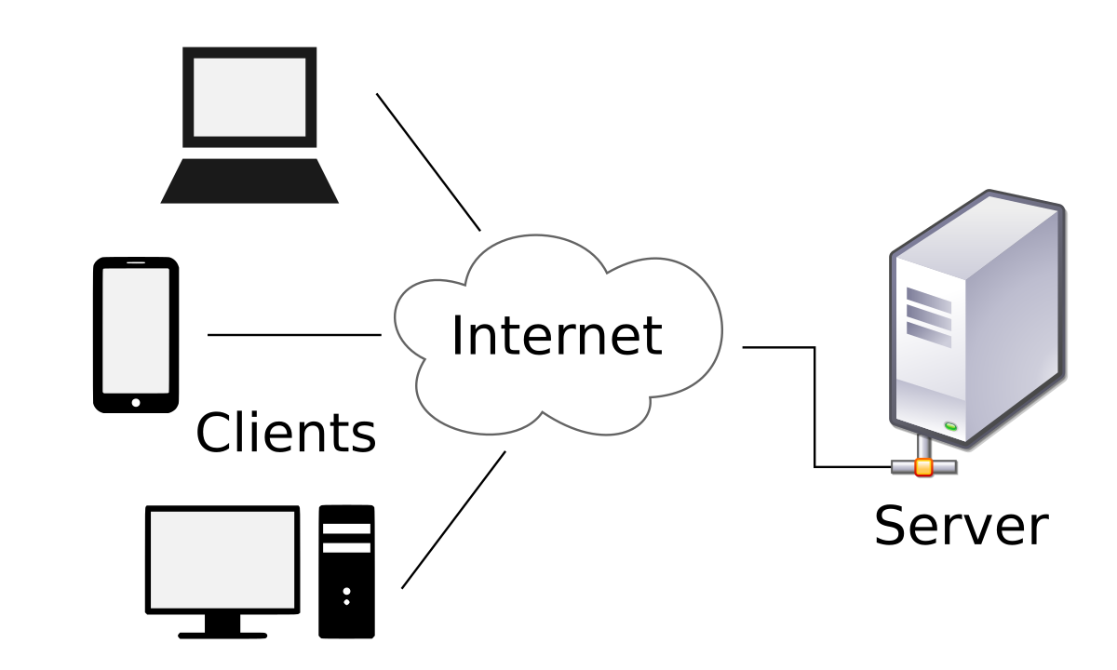

Request: asking for a webpage at a specific URL (path)
What is included in the reponse? Webpage with related data (videos, text, images)

LAN vs WAN
- LAN: Local Area Network
  - Small geo: house
  - Private
- WAN: Wide Area Network
  - Big area: city,
  - Public/private

Peer-to-peer network
- Advs
- Disadv

